Chapter 18: The Fishes: Vertebrate Success in Water
Fish vs. Fishes
- _____________________- notochord, pharyngeal slits, dorsal tubular nerve cord, postanal tail.
What is a Fish?

Evolutionary Evidence
Hagfish are the most primitive living craniates.
2 Key craniate characteristics is: ____________________ and_________________________
530 million years ago possible fossil with brain
500 million years ago bone well developed in group of fishes called __________ (bony armor)
Evolutionary Evidence
- First vertebrates probably marine
- Vertebrates did _____ ___________________and much of the evolution of fish occurred there.
- Early vertebrate evolution involved the movement of fishes back and forth between marine and freshwater environments.
Evolutionary Evidence
The importance of freshwater in the evolution of fishes is evidenced by the fact that over _____ __________________________ even though freshwater habitats represent only ________ ___________________________________ of the earth’s water resources.
________________________________________
- Head-supported by cartilaginous bars
- Brain- enclosed in fibrous sheath
- _________________
- Retain notochord (axial supportive structure)
- 4 pairs of sensory tentacles surrounding their mouths
- Ventrolateral slime glands
Class Myxini
- Found: _______________________
- Feed on: soft bodied invertebrates or scavenge on dead or dying fish
Class Myxini continued…
- To provide leverage, the hagfish ties a knot in its tail and passes it forward to press against the prey
Subphylum Vertebrata
- _______________ that surrounds a ______________and serves as the primary axial support
- Most are vertebrates are members of the ____________________
Jawed fishes
Tetrapods
Class Petromyzontida
- Petros- stone, myzon-sucking
Lampreys -agnathans
- Live in ______________________________
- Larva filter feeders
- Adults prey on fish
  - Mouth –__________ with lips for attachment functions
  - Class Cephalaspidomorphi
- Attach to prey with ______________
- Use tongues to rasp away scales
- Salivary glands with ______________; feed on blood
Sea lamprey Reproduction:
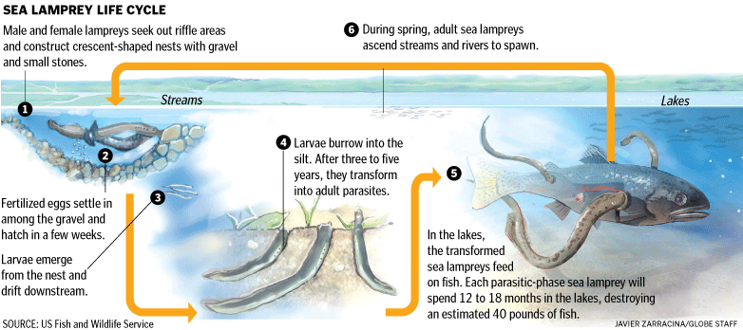

Body parts of fish

Class Chondrichthyes
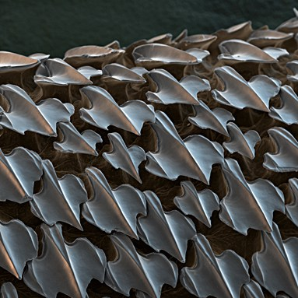
Chondro- cartilage, ichthyes- fish
- Sharks, skates, rays, ratfish
- ______________________________
- Most marine
- Class Chondrichthyes
- Biting mouthparts
- Paired appendages
- ______________________________(gives skin tough, sandpaper texture)
- Cartilaginous endoskeleton
- Class Chondrichthyes
Subclass _________________
elasmos- plate metal, branchia- gills
Sharks, skates, rays
820 species
Placoid scales
- Shark teeth are ________________ ______________________________
  - Rows of teeth
    - As outer teeth wear out, newer teeth move into position from inside jaw and replaces them
Largest living sharks?
- Filter feeders- whale shark
  - Pharyngeal-arch modifications that strain plankton
Draw and label a Dog fish (we are dissecting one later in the week)

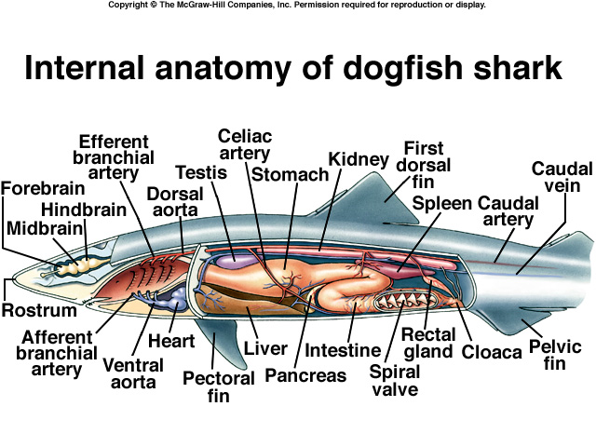

Skates and rays

Life on the ocean floor in shallow waters
Wing like appendages
Camouflage
Osteichthyes
- Osteo- bone, ichthyes- fish
- ________________________________________________
- Bony operculum covering the gill openings
- Lungs or swim bladder
Subclass Actinopterygii
- Actin- ray, pteryx-fin
- Ray-finned fishes because their fins ______________________________
- __________________-gas-filled sacs along the dorsal wall of the body cavity that regulates buoyancy
    - that pop into your head!
What is the largest successful vertebrate group?
- Adapt to environment
- Extract oxygen from small amounts of oxygen per unit volume
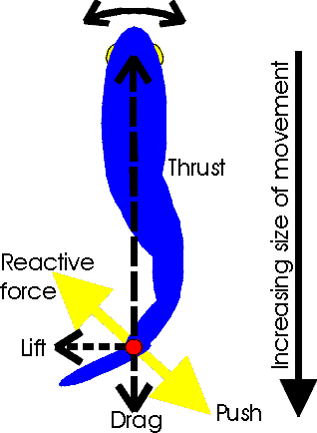
- Efficient locomotor structures
- _____________________________
- Efficient reproduction (produces overwhelming number of offspring)
Locomotion
- Stream line shape
- _________________ lubricates body to decrease friction between fish and water
- Use fins and body wall to push against water.
- The trunk and tail musculature propels a fish.
- Muscles are arranged in _________________ called myomeres; they have the shape of a W on the side of the fish.
- Internally the bands are folded and nested; each myomere pulls on several vertebrae.

Nutrition and Digestion
- Most are predators (always searching for food)
  - Invertebrates, vertebrates
  - ________________________________
  - Capture prey: suction-closing the opercula and rapidly opening mouth
- Some filter feeders- _____________: trap plankton while the fish is swimming with mouth open.

- Some herbivores and omnivores
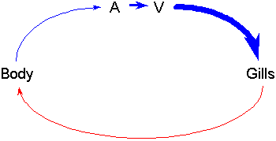
Circulation and Gas Exchange
- The heart only has _______________
- Fish heart only pumps blood in one direction
- The blood enters the _________ through a _____________
- Exits through a vein on its way to the_____________.
- In the gills, the _____________ _____________________ from the surrounding water and leaves the gills in ________________, which go to the body.
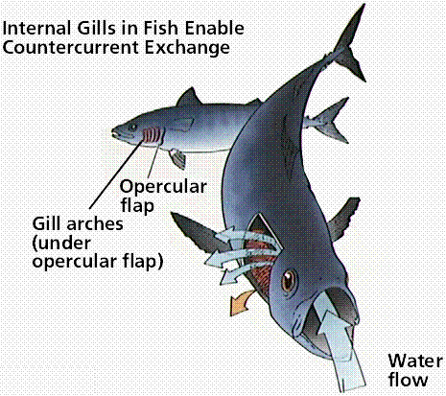
- The _________________in the body and goes ______________.
- A very simple closed-circle circulatory system.
The gills
- the gills are composed of
  - ________________ (which gives the gill rigid support),
  - _________________ (always paired)
  - ________________ (where gas exchange takes place)
- Circulation and Gas Exchange
- The blood flows thorough the gill filaments and secondary lamellae in the __________ __________from the water passing the gills.
- This is very important for getting all of the available oxygen out of the water and into the blood
The countercurrent exchange system
Provides very efficient gas exchange by maintaining a concentration gradient between the blood and the water over the entire length of the capillary bed.

Circulation and Gas Exchange
- How do fish ventilate their gills?
- Fish must pass new water over their gills continuously to keep a supply of oxygenated water available for diffusion.
- Fishes use two different methods
  - ______________________________
  - ______________________________
- Swim through the water and open your mouth (_______________________)
  - include the great white shark, the mako shark, the salmon shark and the whale shark , tuna
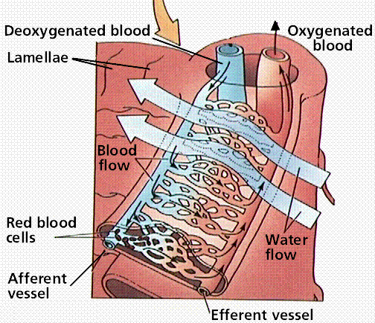
- _____________-help to maintain buoyancy in the water.
  - a sac inside the abdomen that contains gas.
4 Ways Fishes can Maintain their Vertical Position
1. Fishes are saturated with ______________________.
(especially in liver)
2. Use their fins to ___________.
3. Reduction of heavy tissues. (bones less dense,
cartilaginous skeletons)
4. Swim bladder.
Nervous and Sensory Functions
- Has a brain and a spinal cord
- ____________________– in snouts of fishes lead to olfactory receptors
  - Salmon and lampreys return to streams they were spawned from due to the odors
- ___________ – lidless with round lenses; focus by moving lens forward or backward
- ________________– equilibrium, balance, hearing (similar to other vertebrates)
- Nervous and Sensory Functions
- ___________________– sensory pits in epidermis detect water currents (from predators) or low frequency sounds
- _________________ – detection of electrical fields that the fish or another organism generates
  - Highly developed in the rays and sharks
- ______________________– currents circulate from electric organs in fish’s tail to electroreceptors near its head
  - an object in the field changes the pattern
  - Live in murky fresh waters in Africa or Amazon basin in South America
  - EX: electric eel (bony fish)
    - Shocks in excess of 500 volts
  - EX: electric ray (an elasmobranch)
    - Pulses of 50 volts
  - Excretion and Osmoregulation
- _____________________________- maintain proper balance of electrolytes (ions) and water in their tissues
- _____________- excretory structures in the kidneys that filter blood borne nitrogenous waste, ions, water, and small organic compounds across a network of capillaries called: ________________
- Filtrate passes to a _______________ essential components are absorbed into blood filtrate remaining- is excreted
Freshwater Fishes
Never drink!
  - Only take in water when eating.
- Numerous nephrons with ________ glomeruli and SHORT tubule systems
  - Little water reabsorbed
- Large quantities of diluted urine
- Active transport of ions into blood
  - Get salt in their food
Marine Fishes
- Must combat water LOSS
  - 3.5% ions in environment 0.65% ions in tissues
- Drink water
  - Eliminate excess ions by excretions, defection, and active transport across gill.
- Nephrons -___________ glomerculi and LONGER tubule systems
  - Water absorbed from nephrons
- Reproduction and Development
- ____________________________- Lay undeveloped eggs, External fertilization (90% of bony fish), Internal fertilization (some sharks and rays)
  - fish lay huge numbers of eggs; a female cod may release 4-6 million eggs.
- ________________________- Internal development- without direct maternal nourishment-Advanced at birth (most sharks + rays)-Larval birth (some scorpeaniforms-rockfish)
- Reproduction and Development
- _______________________- Internal development- direct nourishment from mother-Fully advanced at birth (some sharks, surf perches)

